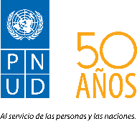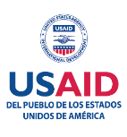

**QUARTERLY PERFORMANCE REPORT**

Period: April - June, 2016

Project: “Strengthening Democratic Governance in Honduras

Through Technical Electoral Assistance and the Promotion of Citizen Security

and a Culture of Peace”

Grant: AID-522-IO-11-00001

UNDP Elections and Citizen Security

Duration: October 1, 2011 – June 30, 2017

Total Budget: USD 7,367,365.79 (Federal)

USD 1,224,654.00 (Non-Federal)

July 2016

**Acronyms and Abbreviations**

ANAMMH: Alianza Nacional de Mujeres Municipalistas de Honduras

AOP or AWP: Annual Operating Plan or Annual Work Plan

ATE Project: *Asistencia Técnica Electoral* (Electoral Technical Assistance) Project

CEM-H: Centro de Estudio de la Mujer Honduras

CESPAD: Centro de Estudio para la Democracia

CIMASC: Comité Interinstitucional de Mecanismos Alternos de Solución de Conflictos.

CNE: *Censo Nacional Electoral* (National Electoral Census)

CSO: Civil Society Organization

FUSINA: Fuerza de Seguirdad Interinstitucional Nacional

GDCA: Grupo de Dialogo Ciudadanía Activa

G-FORT: *Grupo de Fortalecimiento Institucional y Transparencia* (Group for Institutional Strengthening and Transparency)

GSE: *Grupo de Seguimiento Electoral* (Electoral Monitoring Group)

IDECOAS-FHIS: Insitituto de Desarrollo Comunitario, Agua y Saneamiento del Fondo Hondureño de Inversión Social.

INAM: *Instituto Nacional de la Mujer* (National Institute for Women)

INE: *Instituto Nacional de Estadisticas* (National Insitute of Statistics)

LEOP: *Ley Electoral y de Organizaciones Políticas* (Law for Elections and Political Organizations)

LIBRE: *Libertad y Refundación* (Liberty and Refoundation)

MANUD: Marco de Apoyo del Sistema de Naciones Unidas al Desarrollo (UN’s Development Assistance Framework or UNDAF)

MER: *Mesa Electoral Receptora* (Polling Station)

OAS: Organization of American States

PAC: *Partido Anti-Corupción* (Anti-Corruption Party)

PIRs: Performance Indicator Reference Sheets

PMP: Performance Monitoring and Evaluation Plan.

RNP: *Registro Nacional de las Personas* (National Registry of Persons)

SEPLAN: *Secretaría de Planificación* (Planning Ministry)

SPS: San Pedro Sula

TDRs: *Términos de Referencia* (Terms of Reference)

TSE: *Tribunal Supremo Electoral* (Supreme Electoral Court)

UPEG: Unidad de Planificación, Evaluación y Gestión (Planning and Monitoring Unit (UPEG)

UMC: *Unidades de Mediación y Conciliación* (Mediation and Reconciliation Units)

UNAH: *Universidad Nacional Autónoma de Honduras* (National Autonomous University of Honduras)

UNDAF: United Nations Development Assistance Framework (*Marco de Asistencia de las Naciones Unidas para el Desarrollo* or MANUD)

UNDP: United Nations Development Programme

UNFPA: United National Population Fund

USAID: United States Agency for International Development

VAMOS: Name describe for a Political Party

WMOs: Women’s Municipal Office.

**Table of Contents**

EXECUTIVE SUMMARY 6

SECTION 1 – CONTEXT 8

SECTION 2- PROBLEMS, REMEDIAL ACTIONS AND RISKS 10

SECTION 3 - OBJECTIVE RESULTS AND INDICATOR PERFORMANCE TRACKING TABLE 12

SECTION 4 - COLLABORATION AND/OR KNOWLEDGE SHARING WITH OTHER USAID ACTIVITIES 23

SECTION 5 - COLLABORATION AND/OR KNOWLEDGE SHARING WITH GOVERNMENT PARTNERS OR OTHER DONORS 23

SECTION 6 - INTEGRATION OF CROSS-CUTTING VARIABLES 24

SECTION 7 - EVALUATIONS AND LESSONS LEARNED 24

SECTION 8 - LIST OF IN-COUNTRY TRAINING EVENTS 25

SECTION 9 - FINANCIAL INFORMATION 33

SECTION 10 - BRANDING, COMUNICACION AND DISSEMINATION 34

SECTION 11 - ANNEXES: 35

Annex 1 35

Annex 2 36

Annex 3 37

Annex 4 38

Annex 5 39

39

Annex 6 40

Annex 7 41

Annex 8 41

Annex 9 42

Annex 10 43

## EXECUTIVE SUMMARY

This report reflects the main activities and results achieved through the implementation of Grant No. AID-522-IO-11-00001 Electoral Technical Assistance and Citizen from April 1 to June 30, 2016. The financial delivery rate for the reporting period is USD 877,832.09.

# 

As regards the Political Parties and CSO Component of the project, four project-supported electoral reforms proposals were drafted in cooperation with Caritas and the “Active Citizenship” Dialogue Group (*Grupo de Dialogo Ciudadanía Activa*, GDCA) on:

1. Electoral campaign finance;
2. Citizen participation in polling staff;
3. Electoral offenses;
4. Professionalization of electoral bodies.

Proposal no. 1 is expected to be presented to National Congress by September 2016.

Although the Inter-Party Commission did not meet during the reporting period, as a result of periodical bilateral meetings with UNDP, all political parties have confirmed their interest in continuing being part of this dialogue process.

As per the ATE-RNP component, by the end of the first year of implementation, the project had contributed to the drafting of six (6) electoral regulations:

* 1. Regulation on Political Activity, Electoral Propaganda and Campaigns.
  2. Regulation on Practice of Electoral Processes.
  3. Regulation on Equal Opportunities.
  4. Regulation on Performance of Non-Permanent Electoral Organizations.
  5. Regulation on Transparency and Accountability of Political Parties and other forms of Political Organization.

It is expected that TSE will approve and implement at least two of the regulations in the upcoming months.

On April 29, the nationwide student elections were held. ATE supported the training of school directors and teachers in conduct of student election in approximately 22,000 public schools and high schools.

The TSE’s operational units are continuously being supported in implementing 2017 Primary Election Plan. So far, data on 974 voting centers (VCs), covering 42 municipalities and around 940,000 voters has been updated. Additionally, the Census Unit has been provided with hardware and software necessary to ensure the data transfer from the National Registry of People (RNP) to TSE in order to update the National Electoral Census (CNE). TSE will provide the optic cable connectivity.

Five TSE’s Electoral Training and Civic Education officers participated in the international workshop on electoral and civil education training held in Guadalajara, Mexico, on June 22 2016.

With the support of the project, RNP is continuously working on identifying and address inconsistencies in the civil registry database; on reducing underreporting of deaths (See Annex 3); as well as on improving the institution security standards. A proposal for reforms to the RNP law has been drafted and is currently under review of the RNP Directors. It is expected to be submitted to National Congress in the following months.

Steps have been taken to improve under registration and under identification in 8 prioritized municipalities. UNDP is working with different CSOs (See Annex 2), to identify and recruit personnel that will implement this registration.

As per the Coexistence and Citizen Security component, 21 citizen security bulletins were published by IUDPAS with the support of UNDP, including annual and quarterly reports on deaths from external causes in 2015 in the five municipalities of intervention. Even though homicide continues to be the main cause of death from external causes, the total number of violent deaths in Honduras experienced a 7.8% reduction in comparison with 2014. Local homicide rates in the five target municipalities showed different patterns: while the Central District, San Pedro Sula and Tela experienced a reduction in the rate, La Ceiba and Choloma showed a slight increase.

In June, the first Inter-municipal Forum on "Culture of Peace and Violence Prevention: a Democratic Challenge" was held in Tela, with the aim to gather local actors in the field of violence prevention in order to exchange experiences, good practices and lessons learned during the implementation of local policies on culture of peace and violence prevention.

The implementation rate of the local Coexistence and Citizen Security Annual Operating Plans in the target municipalities increased as follows: Tela: + 6 percent; Choloma: + 18 percent; San Pedro Sula: + 6 percent; La Ceiba: 0 percent; Central District: +36 percent. During the reporting period, accountability meetings were held in the 5 municipalities in order to validate the local Coexistence and Citizen Security Annual Operating Plans 2016.

Six community-prioritized projects have been designed and are being implemented under the CPTED methodology in the Central District, San Pedro Sula and Tela in cooperation with IDECOA/FHIS and local authorities. Five more projects are expected to be implemented in the following weeks in Tela, Choloma and La Ceiba.

During the reporting period, UNDP provided technical assistance to the Interagency Committee on Alternative Conflict Resolution Mechanisms (CIMASC) established by the Supreme Court of Justice in order to draft a proposal of Public Policy on Alternative Conflict Resolution Mechanisms. As per June 2016, CIMASC counts on an approved work plan for the rest of the year.

During the second quarter of the year, mediation and conciliation units (UMCs) supported by the project attended 634 people in the five municipalities. Out of those, 326 took part to mediation and conciliation and 62 reached a direct agreement through negotiations thanks to the guidance provided by UMCs.

A total of 3,718 women were attended by the Women Municipal Office (WMO) in the five municipalities during the first year of the project implementation (July 2015-June 2016). During the same period, UNDP-funded youth-oriented prevention activities implemented as part of the project included mapping violence prevention youth and cultural actors in the five municipalities; organizing municipal youth networks for peaceful coexistence; promotion of recreation, physical education, arts, culture and a proper use of leisure time through youth-led communications strategies and the implementation of the Creative and Recreational Holidays methodology in the five municipalities, targeting over 2,000 beneficiaries.

The project local office in Tela was official inaugurated in May 2016, allowing UNDP to strengthen its cooperation bonds with local authorities, social organizations and selected communities in order to implement the project form the field in a more efficient way.

## SECTION 1 – CONTEXT

The second quarter of the year has been characterized by political discussions on the legitimacy of the presidential re-election, which exacerbated an already polarized political arena as a result of the questioned election of the Magistrates to the Supreme Court of Justice. The ruling National Party carried out a process of collecting signatures from party members in order to support a citizen initiative law for regulating the presidential re-election through a reform to the Political Organization Electoral Act (LEOP). Nevertheless, political opposition argues that any political decision on re-election should be submitted to a plebiscite/referendum.

Those political discussions have implied a slowdown in the project-supported debate of electoral reforms. It is expected that the National Party will seek the support of LIBRE and PAC in order to regulate re-election through National Congress in exchange for appointing PAC and LIBRE representatives both at the TSE and RNP. On the other hand, the Liberal Party is firmly opposing presidential re-election and considers that the most needed electoral reform is related to the establishment of a two-round system presidential election.

The Support Mission on Corruption and Impunity in Honduras (*Misión de Apoyo contra la Corrupción y la Impunidad en Honduras*, MACCIH), resulted from an agreement signed by the Government of Honduras and the organization of American States (OAS), officially started its activities in April. MACCIH interventions will be focused in the following issues: 1) murder of human rights defender Berta Caceres, 2) National Police vetting 3) political campaigns finance and 4) corruption cases involving public officials.

As a result, the TSE formally submitted to the MACCIH a proposal of Regulation for Transparency and Accountability of Political Parties and other forms of Political Organization, which was drafted and revised through the ATE Component assistance, in order to use it as main input to formulate a Bill on Political Finance. It is expected that by August 2016, the National Congress will begin discussion to approve the Law on Funding, Transparency and Control of Political Parties and Political Campaigns.

Within the described polarized political arena, TSE is discussing the proposed Regulation on Gender Parity and Alternation with key stakeholders. Both women’s organizations and female members of some political parties are exerting public pressure on TSE in order to reach the goal of a fast adoption of this regulation.

The Ministry of Finance is yet to disburse a first installment of the 485 million Lempiras approved to cover the cost of holding the Primary Elections, affecting the TSE capacities to hire election personnel and purchase election material.

Four out of the five newly-established political parties have not met the minimum requirement of 62,309 signatures needed to be formally registered with the TSE. The only party who managed to meet the requirements has been “VAMOS” (by its name in Spanish), led by former Christian Democracy Political Party member Augusto Cruz Asensio. Consequently, TSE is expected to officially allow “VAMOS” to take part to the next elections, which would increase the number of political parties to nine.

In May, an incident involving RNP employees in Siguatepeque delivering false ID cards was reported. The security forces arrested the employees accused of malpractice while FUSINA secured RNP’s database.

Important progress was registered regarding the National Police vetting process. Events were triggered by a New York Times article linking National Police officers to the deaths of Arístides González, former Director of the Anti-Drug Trafficking Directorate, and security expert Alfredo Landaverde. These allegations, coupled with pressure from inside and outside the country, led to the President of the Republic to appoint a Special Commission for Police Vetting and Transformation. So far, out of 272 police officers which underwent an evaluation process, 106 have been relieved from their duties, including 5 General Directors, 27 General Commissioners, 36 Deputy Commissioners, and 38 Commissioners.

Meanwhile, Congress in considering two bills aimed at reforming the National Police Act and at establishing a new Penal Code. Both of them have the potentiality to produce significant impact in the institutional and social life of the country.

Increasing insecurity among local public transportations companies forced some of them to go temporarily out of business, mainly in northern Honduras. According to UNAH-IUDPAS figures, 209 people in the transportation sector violently died in 2015, up 130.2 percent compared to 2010. As per 2016, UNAH-IUDPAS registered 63 deaths and seven buses incinerated so far.

San Pedro Sula, La Ceiba, Tela, Choloma and the Central District have shown a trend towards strengthening efforts for comprehensive, inter-agency coordination and for articulation of various local actors around Coexistence and Citizen Security Operational Plans. In this regard, local bulletins on violence have been used as a reference for the design and implementation of evidence-based interventions at the municipal level, including social and situational crime prevention activities, deterrence and control actions, peaceful conflict resolution mechanisms, recreation, arts, culture, sports and entrepreneurship.

## SECTION 2- PROBLEMS, REMEDIAL ACTIONS AND RISKS

|  |  |  |
| --- | --- | --- |
| **Objective 1 – Honduras Electoral System -** Result One: Electoral legal and regulatory framework improved | | |
| **Problems encountered**: | **Risks:** | **Proposed remedial actions:** |
| 1. Political context complex and volatile, making difficult to achieve consensus on electoral reform issues. | No electoral reforms formulated and implemented, neither legal nor regulatory, due to political frictions amongst key stakeholders. | Maintain spaces for dialogue, such as the one generated through the Inter Party Commission on Dialogue and Agreements for Electoral Reform meetings that allows key stakeholders to discuss electoral reforms topics in an open and respectful manner.  Moreover, to ensure there is room for a dialogue such as the G16/Electoral Discussing Board to discuss electoral and political issues and scenarios in order to generate and provide inputs to Ambassadors and Representatives, which could help to influence political leaders on electoral reforms needs.  Additionally, continue with the G16’s discussion Board for women political participation meetings in order to discuss and plan strategies to seek synergies with political parties and other key stakeholders to foster indicatives pro women political participation and promotion. |
| 1. Delays in the revision process of the regulations identified. | Electoral Regulations (6 regulations) have to be approved before the announcement of the Primary Elections date. | To continue working closely with the TSE Plenary of Magistrates in order to finalize the revision of the draft regulations and to have them passed and published. |
| 1. Decision making at the TSE Magistrate Plenary is very slow | The electoral calendar could be delayed in its implementation, due to the delays on the Decision Making process of the Magistrates | Urge to the TSE Plenary of Magistrates the importance of having implemented actions and decisions following the electoral calendar. |
| 1. Weakness and low interest of some civil society organizations to promote electoral reforms | Electoral reforms proposal from civil society could be out of time, because its discussion should be before TSE convenes primary elections in September. | To identify other organizations with better capacity and strengths, expanding spaces for exchange and networking. |
| **Result Two: Electoral institutions´ administration improved** | | |
| 1. Lack of decision making by TSE regarding the implementation of initiatives and actions that have an impact of the execution of electoral projects. | Not meeting the deadlines of critical electoral projects turning administration of the 2017 Primary Election on even more complex. | Urge the TSE Magistrates to implement decisions considering the tight deadlines of the 2017 Primary Election Electoral Chronogram. |
| 1. Lack of financial resources to implement electoral projects for 2017 Primary Elections. | Not to properly implementing the electoral regulations and meeting critical dates reflected in the 2017 Primary Election Electoral Chronogram. | Urge the TSE Magistrates to continue lobbying to the appropriate authorities so, funds are disbursed as soon as possible. |
| 1. RNP quick intervention in incident involving their employees delivering illegal ID cards. | Delays in the implementation of ATE and RNP Components’ initiatives due to untimely in the decision making by RNP authorities. | Keep track on the progress of the RNP intervention and continue for advocate for proper implementation of ATE and RNP Components’ initiatives. |
| 1. Although the ‘**Document of recommended activities to implement for an increased information security rate in the RNP’** has been prepared and submitted to RNP, due to delays within the RNP, initial tasks have not been completed to implement the recommendations. | Increase of the safety rate within the project timeframe, will not be implemented. | Meetings have been scheduled with the directors of the institution and heads of the information and technology department to define which security domains will have to be addressed by the component.  The Management Committee of Information Security will be soon established, and will be responsible to review compliance with security policies. |
| **Objective 2 – Inclusive mechanisms that respond to citizen security needs improved** – Result One: Access to secure and reliable data improved | | |
| **Problems encountered** | **Risks** | **Proposed remedial actions** |
| The selection process of the Civil Society Organizations (CSOs) expected to perform the collection of information is faced with delays | The activity results are reached beyond the designated timeframe, that could be delayed in its implementation | Administrative solutions have been sought to expedite the hiring process of the identified CSOs. |
| Result Two: Quality and inclusive public policies and services that improve citizen security enhanced | | |
| Weaknesses are still detected in certain municipal office management areas in targeted municipalities. | Actions in annual operating plans are not properly executed | Build technical capacity within municipal offices through courses and workshops |

## SECTION 3 - OBJECTIVE RESULTS AND INDICATOR PERFORMANCE TRACKING TABLE

***Objective 1 – Honduras Electoral System Strengthened –***

***Result One: Electoral legal and regulatory framework improved***

***Political Parties and CSO Component***

Between April and June 2016, and in cooperation with Caritas and the “Active Citizenship” Dialogue Group (*Grupo de Dialogo Ciudadanía Activa*, GDCA), four electoral reforms proposals from a citizen’s perspective were drafted and presented to civil society organizations and media in Comayagua, San Pedro Sula and Tegucigalpa.

The reform proposals cover the following topics:

1. Electoral campaign finance;
2. Citizen participation in polling staff;
3. Electoral offenses;
4. Professionalization of electoral bodies.

Proposal no. 1 is expected to be presented to National Congress by September 2016.

During the reporting period, more than 10 civil society organizations (including ACI-Participa, ANAMMH, ASONOG, Caritas, CEM-H, CESPAD, CIPRODEH, Commerce of Chamber of Tegucigalpa, FOPRIDEH, GDCA and GSC) took part into de participatory drafting of a [Citizen Advocacy Plan](http://www.eventbrite.com/e/disrupting-democracy-growing-a-new-generation-of-voter-engagement-tickets-16652020642) for Electoral Processes. Among other initiatives, the plan includes the functioning of a civil society network for advocacy and social monitoring of political processes.

Bilateral meeting between UNDP and political parties’ representatives (Liberal, LIBRE, Nacional and PAC) were held during the reporting period. Although the current political polarization prevented the celebration of a new meeting of the Inter-Party Commission, all political parties have confirmed their interest in continuing being part of this dialogue process.

In a joint effort with NDI, NIMD and UN Women, UNDP has provided opportunities for dialogue between parliamentarians, women leaders of political parties, civil society organizations and inter-party group of women to discuss a proposal for a regulation of parity and alternation. This proposal was presented to the TSE and the TSE socialized it with political parties. Currently, this group of organized women is awaiting the approval of the Regulation.

OUTCOME INDICATOR: 1.1

|  |  |
| --- | --- |
| **Indicators** | **Indicator performance** |
| 1.1 Number of Electoral legal reform proposals supported by UNDP/USG presented to the National Congress. | Target set to June 2016: 1  To June 2016: 0 |

During the implementation period, legal advice and logistical support were provided to TSE on the drafting and revision of the proposal of Regulation for Transparency and Accountability of Political Parties and other forms of Political Organization, which was lately submitted to MACCIH as a means to stimulate the political debate on this specific reform.

Additionally, technical and legal assistance was provided to TSE in the formulation of a regulation on Enrollment of Political Parties Movements that most likely will be approved by August this year.

By the end of the first year of implementation, the project had contributed to the drafting of six (6) electoral regulations:

* 1. Regulation on Political Activity, Electoral Propaganda and Campaigns.
  2. Regulation on Practice of Electoral Processes.
  3. Regulation on Equal Opportunities.
  4. Regulation on Performance of Non-Permanent Electoral Organizations.
  5. Regulation on Transparency and Accountability of Political Parties and other forms of Political Organization.
  6. Regulations on Parity and Alternation Mechanism.

Regulations 1 and 6 have thoroughly been reviewed, while regulation 3 has been partially revised. The remaining regulations are going to be revised in the following months by the TSE with the technical assistance of the project staff.

OUTCOME INDICATOR: 1.2

|  |  |
| --- | --- |
| **Indicators** | **Indicator performance** |
| * 1. Number of reforms to the electoral regulatory framework supported by UNDP/USG adopted by the Electoral Supreme Court (TSE). | Target set for June 2016:  Stage 1: Drafted – 6 out of 6 reforms.  Stage 2: Revised and presented for public/stakeholder consultation – 3 out of 6 reforms.  Stage 3: Approved by TSE - 3 out of 6 reforms.  To June 2016:  Stage 1: Drafted – 7 out of 6 reforms.  Stage 2: Revised and presented for public/stakeholder consultation – 2 out of 6 reforms.  Stage 3: Approved by TSE - 0 out of 6 reforms. |

***Objective 1 – Honduras Electoral System Strengthened –***

***Result Two: Electoral institutions´ administration improved***

Technical, logistical and financial support has been provided to both TSE and RNP in developing their Interconnection System in order to build a better National Electoral Census (CNE). The following equipment (hardware and software) has been purchased and donated to the two institutions:

• 8 Dimms of Memory (16 GB)

• 16 hard drives (1 TB) for main and backup databases servers.

• 20 appliance (firewalls) for main and backup databases.

• 2 firewalls FortiCare 200D for the protection of transfer channel.

• 1 console of security FortiDB 500D for databases.

Technical assistance to RNP also included the development of the Inconsistencies Review Module, which was incorporated into the system for comparing in the Identification and Civil Registry Databases. Technical and user’s manuals of the Module were drafted, and 12,000 cases of inconsistencies in 20 selected municipalities were identified in order to be verified.

TSE received relevant support on the issue of the Electoral Bulletin “Connected to citizenry”, as well as for the implementation of the Student Government elections, which were held on April 29.

TSE Electoral Training and Civic Education Unit received financial and logistic support to design and delivery training workshops for school directors, teachers and students in order to provide them with practical knowledge on Student Government organizations. (See Annex 6). A total number of 4,484 teachers was reached in 15 cities (15 departments) nationwide (See Annex 8), exceeded in 3% (See Annex 7) the target. Additionally, 903 students in 18 schools in the Central District were targeted with specific training workshops.

Student Government elections took place in 22,400 public schools, with 2.5 million children and young students casting their votes and electing their authorities (See Annex 10). In comparison with last year, 5,400 more schools and 800,000 more students took part to the elections. Election observation was performed by project staff, which could verify the effectiveness of the training workshops as voting students, were fully aware of their actions during election day.

Moreover, the following TSE initiatives were supported by the project during 2016:

1. Design of training modules
2. Design of the handbook titled "Know your citizen rights and responsibilities"
3. Design of a guide that describes the election process for the Supreme Court of Justice.
4. Development of online résumé registration component as part of the Comprehensive Electoral Training and Civic Education System.
5. Design of graphics for electoral training documents:
   1. Flyers on 2017 Primary Election actors.
   2. Guide to 2017 Primary Elections.
   3. Handbook of frequently asked questions.
   4. Electoral crimes poster (TSE Magistrates approval pending).

During the implementation period, TSE Cartography Unit received technical support on the implementation of the 3rd phase of the Electoral Geographic Political Division (DPGE) Updating Project in the Departments of Yoro, Colon, Atlántida and some municipalities of the Department of Olancho. As a result, 42 municipalities were visited updating the information of 974 voting centers where approximately 940,000 voters cast their vote (See Annex 4). To date, DPGE Updating Project has been conducted in **213** of out **298 municipalities** of **12 departments** in the country representing approximately **75% (3,980)** of the voting centers where **82% of the eligible voters** in the National Electoral Census (CNE).

During the same period, the National Electoral Census has been updated by approximately 20%, and the Electoral Training Project reached a 20% implementation level.

On June 22, five TSE officials participated in the International Workshop on Electoral Training and Civic Education that was held in the State of Jalisco, Mexico. The event was the occasion to exchange best practices and experiences between the TSE of Honduras, the National Civil Registry of Colombia, the National Electoral Institute (INE) of Mexico and the Mexican Agency for International Development Cooperation (AMEXCID)[1] on electoral training and civic education programs.

The ATE Component supported the TSE’s Planning and Monitoring Unit (UPEG) Workshop: "Defining the Requirements for the Development of the Planning and Electoral Monitoring System", that will enable the TSE systematic monitoring and proper implementation of the 22 electoral projects contained in the 2017 Primary Election Plan. Currently, the TSE is evaluating the Terms of References (TORs) of IT consultants to undertake the development of the system.

Finally, the RNP Information Management Committee is about to be established with the aim to increase the security index of the RNP data center.

OUTCOME INDICATOR: 2.1, 2.2, 2.3, 2.4 & 2.5

|  |  |
| --- | --- |
| **Indicators** | **Indicator performance** |
| 2.1 At least three initiatives to update the National Electoral Census. | **Target set until 2nd year (June 2017):** At least 3 initiatives  To June 2016: 0 |
| 2.2 Number of civic-electoral outreach initiatives led by TSE. | **Target set to June 2016: 2**  To June 2016: 2 |
| 2.3 Percentage of actions executed of three electoral projects implemented by TSE. | **Target set to June 2016:**  **Cartography/Mapping: 70%**  **Census: 50%**  **Electoral Training: 60%** |
| 2.4 Percentage of decrease in the delivery time of the identity card in selected municipalities. | **Target set to June 2016: 0 (TARGET SET TILL SECOND YEAR).** |
| 2.5 Percentage of increase in the security index achieved by the RNP data center. | **Target set to June 2016: 7.50%**  **To June 2016: It has not been able to measure it yet.** |

***Objective 2 – Inclusive mechanisms that respond to citizen security needs improved - Result One: Access to secure and reliable data improved***

As part of the projects activities, during the reporting period, UNAH-IUDPAS published 21 citizen security bulletins, which are available for download through the IUDPAS website: <http://www.iudpas.org/boletines> .

As already reported in previous Quarterly Performance reports, the following municipal homicide rates were registered in 2015:

* La Ceiba: 104.8 per 100,000 inhabitants (+ 10.2 compared to 2014);
* Choloma: 90.5 per 100,000 inhabitants (+ 11 compared to 2014);
* Central District: 73.3 per 100,000 inhabitants, (-7.7 compared to 2014);
* San Pedro Sula: 110.5 per 100,000 inhabitants (-31.5 compared to 2014);
* Tela: 57.4 per 100,000 inhabitants (-12.3 compared to 2014).

At the national level, 8034 deaths were attributed to external causes during the January-December 2015 period, down 7.8 percent (685) from 2014 (8719). Homicide continues to be the main cause of death from external causes - 64.1 percent of total reported deaths (5,146), down 13.3 percent (790) from the previous year, with the national homicide rate now standing at 60.0 per one hundred thousand inhabitants.

OUTCOME INDICATOR 1.1 & 1.2

|  |  |
| --- | --- |
| **Indicators** | **Indicator performance** |
| 1.1 Number of bulletins published by the University Institute Democracy, Peace and Security (Instituto Universitario Democracia, Paz y Seguridad), IUDPAS with UNDP/USG support. | Target set to June 2016: 21 bulletins  **To June 2016:** 21 bulletins have been published:  1 National Bulletin on deaths from external causes in 2015.  5 local bulletins on violence and crime during the January-March 2015 period.  5 local bulletins on violence and crime during the January-June 2015 period (Central District, San Pedro Sula and Tela).  5 local bulletins on violence and crime during the January-September 2015 period.  5 local bulletins on violence and crime during the January-December 2015 period. |
| 1.2 Number of people registered or identified in RNP records in areas prioritized by the project during identification brigades | **Target set to June 2016: 0 (TARGET SET TILL SECOND YEAR).**  Networking with different Civil Society Organizations inviting them to participate on under registry and under identification information collection processes in the target areas was conducted.  Development of design and technical specifications of promotional material to be used for activities for reducing rates of under registry and under identification (shirts, vests, hats, pens, briefcases, posters, brochures, etc.) was finalized.  Updating and printing of control books of under registration of births, under registration of deaths and under identification, to perform information collection, was performed. |

During the implementation period, a Citizen Security Diploma course has been designed and launched in cooperation with IUDPAS, with the aim to provide 30 local municipality officials, justice operators and personnel of the local violence observatories with theoretical and practical tools to design and implement evidence-based violence prevention actions, as well as to engage and empower citizens and their organizations in order to improve citizen security levels based on peaceful coexistence.

The course includes the following models:

* Citizen Security, approaches and focus;
* Criminal Justice;
* Gender and Human Rights;
* Violence Prevention;
* Citizen Participation and Empowerment;
* Culture of Peace; and
* Local Planning for Coexistence and Citizen Security.

**Municipal Management:**

During the reporting period, accountability meetings were held in the 5 municipalities of intervention in order to allow local authorities and all stakeholders to validate the activities included in the local Coexistence and Citizen Security Annual Operating Plans 2016, as well as the respective allocation of resources.

In the Central District, the accountability meeting was the occasion to assess the implementation of the AOP 2016 during the first semester of the year. As a result, 36 percent of the Activites included in the plan were considered achieved, 42 percent partially achieved, and 22 percent to be implemented in the second semester of the year. The mid-year assessment of AOP 2016 in the remaining four municipalities will be held during the third quarter of the year.

Outcome Indicator: 2.1

|  |  |
| --- | --- |
| **Indicators** | **Indicator performance** |
| 2.1 Percentage of actions executed increased from the Annual Operatives Plans in each target Municipality. | **Target set to June 2016:**  Tela: + 3%;  Choloma: +3 %;  SPS: +3 %;  La Ceiba: +3 %;  Central District: 30%  **Indicator to June 2016:**  Tela: + 6%;  Choloma: +18%;  SPS: + 6 %;  La Ceiba: +0 %;  Central District: 36% |

As part of the activities of this outcome, the first Inter-municipal Forum on "Culture of Peace and Violence Prevention: a Democratic Challenge" was held in Tela on June 22 and 23, aiming to establish a space for inter-municipal dialogue on experiences, good practices and lessons learned during the implementation of culture of peace and violence prevention local policies.

The forum allowed establishing links between community, municipal and national levels, and was attended by representatives of San Pedro Sula, Choloma, Tela, La Ceiba and the Central District, as well as by representatives of national institutions such as, among others, the Ministry of Security, the National Youth Institute, IDECOAS-FHIS, UNAH.

Three conferences were held during the event:

1. *Culture of Peace, Coexistence and Human Rights*, delivered by international consultant Ricardo Herrera;
2. *Peace and Social Prevention of Violence in Colombia: The Experience of the Municipality of Bello*, delivered by Carlos Lopera, Coordinator of UNDP’s Local Office in Antioquia, Colombia; and
3. *Municipal Public Policy for Violence Prevention: Progress and Challenges*, delivered by Rigoberto Ochoa, UNDP Project Coordinator.

Among the successful experiences and good practices presented during the event, is worth highlighting the Creative and Recreational Holidays methodology; the functioning of the Municipal Prevention Committee "La Ceiba for Everyone"; the activities of the Municipal Mediation and Conciliation Unit in SPS; the construction of community parks in the Central District; the activities of the Women's Network "Free Butterflies of Tornabé"; interventions in art and culture in Comayagüela markets; the fund to create opportunities for youth entrepreneurship; local planning for violence prevention; mainstreaming of the gender approach in coexistence and citizen security operational plans; community-based interventions with CPTED-PEC methodologies; and the Safer Municipalities Program, among others.

**Crime Prevention Trough Environmental Design (CPTED):**

Following the Project Prioritization Assemblies held in 11 communities of the 5 targeted municipalities – where local communities had the opportunity to choose the projects to be implemented under the PEC (community-implemented projects) methodology – and appointment of local Project Implementing Committees (CEP), IDECOAS-FHIS designed 6 projects to be implemented in the upcoming months:

1. Building of a sanitation module in Naciones Unidas School in Colonia Villanueva, Tegucigalpa;
2. Building of vehicle tracks in Colonia Los Pinos, Tegucigalpa;
3. Improvements to the public lighting system in Colonia El Retiro, Tela;
4. Improvements to the public lighting system in Colonia Grantt, Tela;
5. Construction of construction of bus stops in Chamelecón, San Pedro Sula;
6. Construction of bus stops in Sector Rivera Hernández, in San Pedro Sula.

The five remaining projects, whose design is expected to be completed by August 2016, include:

1. Improvements to the public lighting system in Colonia15 de Septiembre, Tela;
2. Improvements to public parks and recreation facilities in Colonia Victoria, Choloma;
3. Construction of a drain system in Colonia Gale, Choloma;
4. Improvements to the public lighting system in Barrio La Isla, La Ceiba;
5. Improvements to pedestrian crossing in Colonia Las Delicias, La Ceiba.

Outcome Indicator: 2.2

|  |  |
| --- | --- |
| **Indicators** | **Indicator performance** |
|
| 2.2 Number of infrastructure projects using CPTED methodology implemented in selected communities led by municipal officials. | **Target set to June 2017: 10 infrastructure projects with CPTED methodology.**  **Indicator to June 2016:**  6 of 11 projects prioritized by communities designed and formulated. Percentage of progress: 54.5%, equivalent to 6 out of 11 design plans.  Central District: 2; San Pedro Sula: 2; Tela: 2 |

**Mediation and Conciliation:**

During the implementation period, UNDP has supported the Supreme Court of Justice in the establishment of the Interagency Committee on Alternative Conflict Resolution Mechanisms (CIMASC), an initiative which combines the efforts of the Judicial and Executive (Governance and Decentralization Cabinet) branches of Government toward the development of a Public Policy on Access to Justice, including the strengthening of Alternative Conflict Resolution Mechanisms both at the national and the local level.

UNDP actively participates on CIMASC meetings, which led to the approval of a Work Plan for the rest of the year, and the establishment of a technical committee responsible for the development of a first proposal of the public policy, which is expected to be ready by November 2016. The technical committee is made up by representatives of the Supreme Court of Justice, the Government Cabinet on Governance and Decentralization, the Ministry of Human Rights, the National Directorate for Adolescents and Family (DINAF), UNAH, and local NGO *Asociación por una Sociedad más Justa* (ASJ).

During the second quarter of the year, local units of mediation and conciliation attended for the peaceful solution of conflicts to a total of 634 people in the five municipalities, of those 226 received guidance on how to solve the problem in another instance and 326 participated in mediation and conciliation sessions to which 8 persons came invited as guests to discuss the conflict. Out of the people who requested mediation or conciliation, 62 reached a direct agreement through negotiations thanks to the guidance provided by UMCs. Out of the people served, 125 were women and 139 were men; 11 were between the ages of 18 and 25, 60 between the ages of 25 and 35, 82 between the ages of 35 and 45, 63 were between the ages of 45 and 55, and 108 were over 55. As for types of conflict, 46 were family-related; 119 involved neighbors; 16 were community-related; 22 involved civil contracts; 80 involved debts; 34 involved tenancies; and the remaining 3 fall under other categories.

As a result, 2,743 people reached peaceful resolutions of their conflicts during the first year of the project implementation, exceeding the target set at 2500 citizens. Additionally, during the whole implementation period, conferences and workshops on family, neighborhood and community coexistence were held in the communities of the five municipalities of intervention, as part of prevention actions aimed at preventing conflicts from escalating into violent acts. Those activities have been attended by 5,500 citizens and families of all ages and of all ethnic groups.

Outcome Indicator: 2.3

|  |  |
| --- | --- |
| **Indicators** | **Indicator performance** |
| 2.3 Number of instruments formulated to use alternative conflict resolution mechanisms. | **Target set to June 2016: 1**  (Target set till second year): 2    **To June 2016**, there is a CIMASC work plan to develop public policy on access to justice and MASC. |

Outcome Indicator: 2.4

|  |  |
| --- | --- |
| **Indicators** | **Indicator performance** |
|
| 2.4 Number of people that access alternative conflict resolution mechanisms in targeted municipalities. | **Target set to June 2016: 2,500**  **To June 2016: 2,743** people between July 2015 and June 2016. (people between April and June 2016: 634). |

**Women’s Municipal Offices (WMO):**

During the reporting period, Women's Municipal Office (WMO) Information Systems were reviewed in order to verify whether these were being used effectively to record their activities and the services being delivered, as well as to identify aspects that need improving in both the system’s use and content. To this end, several meetings were held with the National Women's Institute (INAM) and with WMOs as the system's users. Improvements to the system are expected to contribute to making it easier for WMOs to keep proper records of their activities, and to increasing the visibility of the efforts they conduct in favor of women's rights. Making proper use of the system will also enable better tracking of the number of women accessing the various services delivered by WMOs.

Other activities have been conducted with WMOs such as diagnoses of both their capacity and needs in four municipalities. Diagnoses results led to a redistribution of project funds to WMOs in order to enable WMOs to achieve he results set out in local Coexistence and Citizen Security AOPs as well as to support their institutional strengthening.

Diagnoses also helped to identify WMO needs in terms of training given the awareness-raising and training activities they perform and their efforts to assist women and prevent violence against them. Training topics include other forms of violence against women (beyond domestic violence); violence against women and sexual and reproductive health; methodologies for primary care to users and survivors of violence; emotional containment techniques for WMO staff dealing with cases of violence; and security measures for service providers. Educational methodological proposals to be developed in each municipality are ready, along with work schedules tailored to the time each WMO has available to develop programmed activities.

As part of activities, WMOs participated in sessions dedicated to oversight of coexistence and citizen security plans in target municipalities.

Out of 11,375 people assisted by WMOs over the first year of the project implementation, 3,718 sought legal or psychological aid in cases of violence, and legal advice for divorces, child support and other similar cases; while the remaining 7,657 who participated in various training sessions.

Outcome Indicator: 2.5

|  |  |
| --- | --- |
| **Indicators** | **Indicator performance** |
|
| 2.5 Number of women in selected municipalities that access services offered by the Women Municipal Offices (WMO). | **Target set to June 2016**: 1,200  **To June 2016**: 3,718 women accessed services offered by WMOs. |

**Culture and Youth:**

During the reporting period, the project contributed to the mapping, in all five municipalities of intervention, of:

1. Organizations, institutions and groups working on preventing violence against youth; and
2. Cultural and artistic resources, organizations and expressions that can be used as violence prevention tools.

Those Mappings are intended to serve as inputs to improve coordination and harmonization of actions between local governments and citizens, universities, private sector, cooperating agencies, NGOs, etc. working on youth, violence prevention and culture of peace at the local level. This information will also be used by central government institutions working in these same areas so as to align their efforts with those by local governments and municipalities.

Additionally, youth networks for peaceful coexistence were conformed in Municipal Programs for Children, Adolescent and Youth (PMIAJ) in the five municipalities of intervention in cooperation with COMVIDA technicians and the United Nations Volunteer Programme.

Two groups of young people in San Pedro Sula (Warrior Zulu Nation) and Choloma (BATZAMU) were the beneficiaries of training workshops on the design and implementation of communication strategies aimed at promoting positive values, coexistence and a culture of peace. Both groups will be provided with basic equipment during the next quarter in order to implement those communication strategies.

Several workshops and trainings on the Creative and Recreational Holidays methodology were held during the implementation period, aiming to promote physical and mental health in adolescents and youth through recreation, physical education, play, arts, culture and proper use of leisure time. A complete list of these activities is included in section 8 of this Quarterly Performance Report. As a result, each of the five municipalities of intervention counts on a group of facilitators in creative and recreational holidays working from Municipal Child, Adolescent and Youth Offices in partnership with local NGOs, particularly those linked to USAID and with houses of culture, municipal sports offices, and government agencies.

Outcome indicator 2.6:

|  |  |
| --- | --- |
| **Indicators** | **Indicator performance** |
| 2.6 Number of proposals on culture of peace presented by youth to decision-makers. | Target set till second year 2017: 5 |

## SECTION 4 - COLLABORATION AND/OR KNOWLEDGE SHARING WITH OTHER USAID ACTIVITIES

Several DO1 USAID implementers - including Creative-Alianza Joven Honduras/AJH, FUNADEH, GENESIS Projects, Glasswing, Children International, FHIS/IDECOAS, PASMO and Honduras CONVIVE – participated in the Coexistence and Citizen Security AOP 2016 accountability meetings in the five municipalities, thereby establishing a space for coordinating and tracking actions conducted in target municipalities.

Additionally, various DO1 USAID implementers have adopted the Creative and Recreational Holidays methodology in order to build community facilitator capacity in recreation with a holistic approach. UNDP continued providing technical assistance to replications of the Creative and Recreational Holidays initiative being coordinated by Child, Adolescent and Youth Programs in the five target municipalities.

Finally, Creative-AJH, Honduras Convive, PASMO, and FUNADEH took part to the first Inter-municipal Forum on "Culture of Peace and Violence Prevention: a Democratic Challenge", which was held in Tela last June.

## SECTION 5 - COLLABORATION AND/OR KNOWLEDGE SHARING WITH GOVERNMENT PARTNERS OR OTHER DONORS

UNDP and project staff have been actively participation in the G16 thematic roundtables on:

1. Electoral Monitoring;
2. Gender;
3. Justice, Security and Human Rights.
4. Discussing dynamics of the political electoral environment and working on Board’ Strategic Plan for 2016.

Apart from the usual stakeholder, during the reporting period UNDP and Project staff engaged MACCIH and National Congress on electoral reform-related activities.

Representatives of the municipalities of San Pedro Sula, Choloma, Tela, La Ceiba and the Central District, along with officials of the Ministry of Security, the National Youth Institute, IDECOAS-FHIS and UNAH took part into the Inter-municipal Forum on "Culture of Peace and Violence Prevention: a Democratic Challenge".

## SECTION 6 - INTEGRATION OF CROSS-CUTTING VARIABLES

Gender perspective was included among the electoral reforms proposals from the civil society, political parties, congress women, specifically the topic of parity and alternation in voting ballots. In addition, women of CSO have been involved in the design of Citizen Plan for Electoral Processes, around a third of attendance in the workshops.

As follow-up to discussions on the proposed Regulations on Equity and Alternation of Power, the ATE component has continued participating in meetings between TSE and the actors involved (women congress members, members of the Congress' Gender Committee, political party representatives) providing technical and legal advice and support, in order to determine the scope of the regulation and the most suitable alternation mechanism. Related to the political participation of women, later this quarter, UNDP has begun meetings with UN Women, NDI, NIMD and INAM for coordination of the Academia of Candidates which seeks to strengthen the capacities of women who will participate for the first time in an election process. Activities will take place between September and October.

The inclusion of a gender perspective into the implementation of the coexistence and citizen security project resulted in a renewed cooperation with WMOs in the five municipalities aimed at enhancing their technical capacity and public positioning. Additionally, project indicators have been reviewed to allow conducting an analysis of how the mainstreaming of this approach has been conceived in order to identify the paths or steps to follow so that both this and future projects make gender mainstreaming an integral part of all its objectives, actions, results and indicators, and thus achieve more effective and inclusive efforts regarding prevention of violence against women.

## SECTION 7 - EVALUATIONS AND LESSONS LEARNED

1. The current polarized and complex political and social environment highlights the need for maintaining broad discussion with all political actors on the electoral reforms and for strengthening strengthened civil society and multiparty dialogue;
2. The employment of tools such as AWP, PMP, PIRS proved to be useful in the implementation of the project actives;
3. In all the municipalities of interventions, high level of synergy among local authorities, donors and civil society have been registered around the Coexistence and Citizen Security Annual Operating Plans.

## SECTION 8 - LIST OF IN-COUNTRY TRAINING EVENTS

| **Name of the training programed** | | **Field of study** | **Relationship to the objectives** | | **Start date** | | **End date** | **Estimated cost (US$)** | **Number of male** | **Number of female** |
| --- | --- | --- | --- | --- | --- | --- | --- | --- | --- | --- |
| **ATE Component** | | | | | | | | | | |
| International Workshop on Electoral Training and Civic Education amongst Honduras, Colombia, and Mexico | | Electoral Training and Civic Education | It has a deep impact on strengthening the competencies of the Electoral Training and Civic Education Unit staff so they can respond to the TSE demands regarding to the implementation of electoral projects detailed in the 2017 election plan. | | June 21, 2016 | | June 24, 2016 | 11,000.00 | 2 | 3 |
| Defining the Requirements for the Development of the Electoral Planning and Monitoring System | | Electoral planning and monitoring | In order to achieve improvements in the administration of the TSE, it is vital to count with a systematic monitoring and proper implementation of the 22 electoral projects contained in the 2017 Primary Election Plan. Therefore this system will support the monitoring of the activities. | | April 5, 2016 | | April 7, 2016 | 1,200.00 | 13 | 2 |
| **Total ATE component** | | | | | | | | **12,200.00** | **15** | **5** |
| **Citizen Identification Component** | | | | | | | | | | |
| Not applicable for this quarter | | | | | | | | | | |
| **Total Citizen Identification component** | | | | | | | | **-** | **-** | **-** |
| **Total ATE and Citizen Identification component** | | | | | | | | **12,200.00** | **15** | **5** |
| **Coexistence and Citizen Security Component** | | | | | | | | | | |
| **Local Management** | | | | | | | | | | |
| Work session with Choloma’s Prevention Committee | | Establish the space for between Prevention Committee members to monitor and track coexistence and citizen security actions. | Improved inclusive mechanisms that respond to citizen security need  Improved inclusive mechanisms that respond to citizen security need | | April 12, 2016 | | April 12, 2016 | $00.00 | 8 | 12 |
| Session to socialize the implementation proposal for Choloma's Municipal Prevention Office. | | Socialization of analysis of 2016 AOP results with Prevention Committee, as well as acknowledgement of opinions and perceptions of Prevention Committee members regarding the creation of the Municipal Prevention Office of prevention | April 13, 2016 | | April 13, 2016 | $100.00 | 4 | 6 |
| Development of accountability exercise for the 2016 AOP's first semester for Choloma | | Verification of fulfillment of actions established to the first semester of the 2016 AOP | June 10, 2016 | | June 10, 2016 | $700.00 | 14 | 16 |
| Work session with Choloma’s Prevention Committee | | Establish the space for between Prevention Committee members to monitor and track coexistence and citizen security actions. | June 22, 2016 | | June 22, 2016 | $00.00 | 7 | 2 |
| Work session with Choloma’s Prevention Committee | | Establish the space for between Prevention Committee members to monitor and track coexistence and citizen security actions. | June 29, 2016 | | June 29, 2016 | $00.00 | 7 | 5 |
| Workshop to socialize results of implementation of 2015 AOP actions to the Municipal Coexistence and Citizen Security Council and the "La Ceiba for Everyone Municipal Prevention Committee. | | Validation of information from 2015 with local authorities, Municipal Prevention Committee and Civil Society | April 12, 2016 | | April 12, 2016 | $200.00 | 12 | 14 |
| Opening of Municipal Prevention Offices in La Ceiba | | Event to officially hand over the Municipal Prevention Office to Municipal Prevention Committee, by local authorities. | Improved inclusive mechanisms that respond to citizen security need | | April 27, 2016 | | April 27, 2016 | $360.00 | 25 | 16 |
| Session with La Ceiba Municipal Prevention Committee | | Socializing the methodology for the Alternatives to Violence project - Coni Lustemberger | May 3, 2016 | | May 3, 2016 | $ 00.00 | 6 | 8 |
| Inter-municipal Forum on Culture of Peace and Violence Prevention | | Establish a space for inter-municipal dialogue on experiences and good practices in implementing local policy on culture of peace and violence prevention | June 22 | | June 24, 2016 | $ 20,000.00 | 51 | 56 |
| Presentation of results of 2015 AOP fulfillment levels. Tela | | Socialization of analysis of 2015 AOP results and perception of implementation of Municipal Prevention Office | April 15,  2016 | | April 15,  2016 | $400.00 | 11 | 9 |
| Session with Municipal Prevention and Citizen Security Council - Tela | | Fulfillment of internal Regulations | April 6, 2016 | | April 6, 2016 | $ 00.00 | 32 | 16 |
| Session with Municipal Unit technicians to review and validate coexistence and citizen security actions in 2016 AOP - Tela | | Planning strategies with municipal technical team | April 7, 2016 | | April 7, 2016 | $ 00.00 | 15 | 6 |
| Session with Municipal Coexistence and Citizen Security Council, to present 2015 AOP results - Tela | | Present 2015 AOP results and target fulfillment, and statistical data on violence and crime at the end of 2015. | April 15, 2016 | | April 15, 2016 | $500.00 | 14 | 10 |
| Session with Municipal Units to discuss guidelines for oversight of the first half of 2016 - Tela | | Planning strategies and local coordination | Improved inclusive mechanisms that respond to citizen security need | | May 25, 2016 | | May 25, 2016 | $ 00.00 | 13 | 5 |
| Work session with justice operators: Preventive, Traffic and Tourism Police officers, to define guidelines for 2016 AOP oversight report - Tela | | Provide information gathering format to allow verifying actions and results of 2015 AOP oversight report | June 17, 2016 | | June 17, 2016 | $ 00.00 | 4 | 1 |
| First accountability exercise for the 2016 AOP regarding coexistence and citizen security - San Pedro Sula | | First session to verify actions implemented from 2016 AOP | April 13, del 2016 | | April 13, del 2016 | $200.00 | 22 | 28 |
| Work session with Municipal Prevention Committee to set up organizational structure – San Pedro Sula | | Work session with Prevention Committee to operationalize this municipal entity | April 19, de 2016 | | April 19, del 2016 | $ 600.00 | 8 | 19 |
| Session with Municipal Units to analyze roles and responsibilities of municipal actors in Prevention Committee – San Pedro Sula | | Build technical and operational capacity of actors in Prevention Committee | May 19, 2016 | | May 19, 2016 | $ 150.00 | 5 | 18 |
| Session with municipal offices to review reporting formats to be submitted in accountability processes - San Pedro Sula | | Build technical capacity for information management in local actors involved in AOP. | May 20, 2016 | | May 20, 2016 | $100.00 | 7 | 5 |
| Work session with Municipal Prevention Committee to review roles and responsibilities of Board of Directors, and structuring of work plan | | Build technical and organizational capacity of Committee | Improved inclusive mechanisms that respond to citizen security need | | June 9, 2016 | | June 9, 2016 | $ 00.00 | 4 | 14 |
| Workshop to build monitoring and evaluation capacity in municipal offices, with emphasis on indicator-building - San Pedro Sula | | Results-based management | June 7, 2016 | | June 7, 2016 | $ 450.00 | 2 | 5 |
| Session to plan first accountability exercise for the 2016 AOP with Central District Town Hall | | Planning session. | June 27, 2016 | | June 27, 2016 | $00.00 |  | 3 |
| **TOTAL Local Management** | | | | | | | | **23,760** | **271** | **274** |
| **UMC** | | | | | | | | | | |
| Planning session with community coexistence volunteers in La Ceiba, Tela, San Pedro Sula, Choloma and Central District. | | Planning of activities as guide to develop peaceful coexistence in communities | Inclusive mechanisms that respond to citizen security needs improved | | February 2, 2016 | | February 2, 2016 | 9 | 8 | 19 |
| February 3, 2016 | | February 3, 2016 | 100 | 2 | 8 |
| February 4, 2016 | | February 4, 2016 | 200 | 3 | 17 |
| February 5, 2016 | | February 5, 2016 | 200 | 15 | 6 |
| February 10, 2016 | | February 11, 2016 | 362 | 14 | 32 |
| Community motivation and awareness-raising in La Ceiba, Tela, Choloma and San Pedro Sula | | Awareness-raising, training of community mediators, training of coexistence promoters | Prevent conflict escalation by informing, raising awareness and training | | May 18 | | May 18 |  | 29 | 91 |
| Community motivation and awareness-raising in La Ceiba, Tela, Choloma and San Pedro Sula | | Awareness-raising, training of community mediators, training of coexistence promoters | Prevent conflict escalation by informing, raising awareness and training | | May 19,  2016 | | May 19,  2016 |  | 29 | 91 |
| May 19,  2016 | | May 19,  2016 |  | 14 | 31 |
| May 20,  2016 | | May 20,  2016 |  | 29 | 91 |
| May 20,  2016 | | May 20,  2016 |  | 14 | 31º |
| May 21,  2016 | | May 21,  2016 |  | 29 | 91 |
| May 23,  2016 | | May 23,  2016 |  | 26 | 36 |
| May 24,  2016 | | May 24,  2016 |  | 26 | 36 |
| May 27,  2016 | | May 27,  2016 |  | 14 | 31 |
| May 30,  2016 | | May 30,  2016 | 13.240,89 | 26 | 36 |
| May 31,  2016 | | May 31,  2016 |  | 26 | 36 |
| June 6,  2016 | | June 6,  2016 |  | 1 | 39 |
| June 7,  2016 | | June 7,  2016 |  | 1 | 39 |
| June 9,  2016 | | June 9,  2016 |  | 3 | 9 |
| June 9,  2016 | | June 9,  2016 |  | 3 | 9 |
| June 10,  2016 | | June 10,  2016 |  | 16 | 24 |
| June 11,  2016 | | June 11,  2016 |  | 16 | 24 |
| June 12,  2016 | | June 12,  2016 |  | 3 | 9 |
|  | |  |  | | June 13,  2016 | | June 13,  2016 |  | 3 | 9 |
| Community motivation and awareness-raising in La Ceiba, Tela, Choloma and San Pedro Sula | | Awareness-raising, training of community mediators, training of coexistence promoters | Prevent conflict escalation by informing, raising awareness and training | | June 13,  2016 | | June 13,  2016 |  | 1 | 39 |
| June 13,,  2016 | | June 13,,  2016 |  | 16 | 24 |
| June 14,  2016 | | June 14,  2016 |  | 3 | 9 |
| June 14,  2016 | | June 14,  2016 |  | 1 | 39 |
| June 14,  2016 | | June 14,  2016 |  | 16 | 24 |
| June 15,  2016 | | June 15,  2016 |  | 1 | 39 |
| June 16`  2016 | | June 16`  2016 |  | 10 | 4 |
| June 17,  2016 | | June 17,  2016 |  | 10 | 4 |
| June 20,  2016 | | June 20,  2016 |  | 11 | 15 |
| June 21,  2016 | | June 21,  2016 |  | 11 | 15 |
| June 23,  2016 | | June 23,  2016 |  | 10 | 4 |
| June 24,  2016 | | June 24,  2016 |  | 10 | 4 |
| June 27,  2016 | | June 27,  2016 |  | 11 | 15 |
| June 28,  2016 | | June 28,  2016 |  | 11 | 15 |
| June 29,  2016 | | June 29,  2016 |  | 10 | 4 |
| June 30,  2016 | | June 30,  2016 | 6.065,78 | 10 | 4 |
| **Total UMC** | | | | | | | | **21,048.67** | **492** | **1,072** |
| **Culture and Youth** | | | | | | | | | | |
| Second training workshop for facilitators on recreation, art and sports for violence prevention in San Pedro Sula | | Improved inclusive mechanisms that respond to citizen security need | Follow-up to technical and logistical assistance to create youth network for peaceful coexistence in Municipal Child, Adolescent and Youth Programs (PMIAJ). | | April 2 | | April 2 |  | 17 | 22 |
| Creative and Recreational Holidays workshop in Rivera Hernandez sector | |  | Follow-up to technical and logistical assistance to create youth network for peaceful coexistence in Municipal Child, Adolescent and Youth Programs (PMIAJ). | | April 16, | | April 16, | 710.00 | 83 | 110 |
| Creative and Recreational Holidays workshop in Colonia 10 de Septiembre in Chamelecón, coordinated jointly by Child, Adolescent and Youth Program, Town Hall Sports, Town Hall Recreovias, FUNADEH, Warrior Crew, Skate Brothers and UNV volunteer network | |  | Follow-up to technical and logistical assistance to create youth network for peaceful coexistence in Municipal Child, Adolescent and Youth Programs (PMIAJ). | | April 23 | | April 23 | 710.00 | 85 | 130 |
| Training workshop for facilitators on Creative and Recreational Holidays in the Central District | |  | Follow-up to technical and logistical assistance to create youth network for peaceful coexistence in Municipal Child, Adolescent and Youth Programs (PMIAJ). | | April 28 | | April 28 | 350.00 | 28 | 38 |
| Replication workshop on Creative and Recreational Holidays at Centro de Capacitación Especial (Cecaes), coordinated by Municipal Youth Program Comvida - Central District | |  | Follow-up to technical and logistical assistance to create youth network for peaceful coexistence in Municipal Child, Adolescent and Youth Programs (PMIAJ). | | May 6 | | May 6 | 500.00 | 86 | 74 |
| Creative and Recreational Holidays workshop in Colonia Campo Elvir in Tela | |  | Follow-up to technical and logistical assistance to create youth network for peaceful coexistence in Municipal Child, Adolescent and Youth Programs (PMIAJ). | | April 16, | | April 16, | 268.00 | 41 | 59 |
| Creative and Recreational Holidays workshop in Colonia 4 de Enero in Tela | |  | Follow-up to technical and logistical assistance to create youth network for peaceful coexistence in Municipal Child, Adolescent and Youth Programs (PMIAJ). | | April 23 | | April 23 | 268.00 | 58 | 41 |
| Launching of and workshop on Creative and Recreational Holidays in La Ceiba’s Central Park | |  | Follow-up to technical and logistical assistance to create youth network for peaceful coexistence in Municipal Child, Adolescent and Youth Programs (PMIAJ). | | April 15, | | April 15, | 500.00 | 63 | 45 |
| Creative and Recreational Holidays workshop in Colonia San Jose in La Ceiba | |  | Follow-up to technical and logistical assistance to create youth network for peaceful coexistence in Municipal Child, Adolescent and Youth Programs (PMIAJ). | | April 18 | | April 18 | 500.00 | 137 | 67 |
| Creative and Recreational Holidays workshop in Colonia Éxitos de Anach 2, coordinated by the Child, Adolescent and Youth Program | |  | Follow-up to technical and logistical assistance to create youth network for peaceful coexistence in Municipal Child, Adolescent and Youth Programs (PMIAJ). | | April 10 | | April 10 | 187.00 | 52 | 46 |
| Creative and Recreational Holidays workshop in Colonia Las Pilas | |  | Follow-up to technical and logistical assistance to create youth network for peaceful coexistence in Municipal Child, Adolescent and Youth Programs (PMIAJ). | | 2April 6, | | 2April 6, | 187.00 | 56 | 49 |
| Replication workshop on Creative and Recreational Holidays (Smiles from my Neighborhood), coordinated by the Municipal Youth Comvida in Aldea Bijao in Choloma | |  | Follow-up to technical and logistical assistance to create youth network for peaceful coexistence in Municipal Child, Adolescent and Youth Programs (PMIAJ). | | May 28 | | May 28 | 187.00 | 28 | 60 |
| Third replication of Creative and Recreational Holidays workshop in  Comunidad de Bijao, Choloma | |  | Follow-up to technical and logistical assistance to create youth network for peaceful coexistence in Municipal Child, Adolescent and Youth Programs (PMIAJ). | | June 1 | | June 1 | 185.00 | 48 | 42 |
| First workshop on communication tools and techniques for community youth spokespersons in Choloma and San Pedro Sula | |  | Develop a communication for life strategy including two youth groups in community radio and local cable, as well as creation of blogs linked to social networks. | | June 12 | | June 18 | 4,540.00 | 8 | 12 |
| **TOTAL Culture and youth** | | | | | | | | **9,092** | **790** | **795** |
| **Women’s Municipal Office** | | | | | | | | | | |
| Reflecting on our Possibilities workshop - WMO in La Ceiba | Make a diagnosis of the current situation in terms of WMO capacity and resources, and define an activities plan to implement the project. | | | Inclusive mechanisms that respond to citizen security needs improved | | May 3,  2016 | May 4,  2016 | 465.72 | 0 | 8 |
| Reflecting on our Possibilities workshop - WMO in Tela | Make a diagnosis of the current situation in terms of WMO capacity and resources, and define an activities plan to implement the project. | | | Inclusive mechanisms that respond to citizen security needs improved | | May 5,  2016 | May 6,  2016 | 596.66 | 0 | 6 |
| Reflecting on our Possibilities workshop - WMO in San Pedro Sula | Make a diagnosis of the current situation in terms of WMO capacity and resources, and define an activities plan to implement the project. | | | Inclusive mechanisms that respond to citizen security needs improved | | May 17,  2016 | May 17,  2016 | 428.18 | 1 | 15 |
| Reflecting on our Possibilities workshop - WMO in Choloma | Make a diagnosis of the current situation in terms of WMO capacity and resources, and define an activities plan to implement the project. | | | Inclusive mechanisms that respond to citizen security needs improved | | May 18,  2016 | May 18,  2016 | 283.26 | 0 | 6 |
| **Total WMO** | | | | | | | | **1,773.82** | **1** | **35** |
| **TOTAL Citizen Security Component** | | | | | | | | **55,674.49** | **1,554** | **2,176** |
| **TOTALS January – March 2016 (all components)** | | | | | | | | **67,874.49** | **1,569** | **2,181** |

## SECTION 9 - FINANCIAL INFORMATION

As at June 30, 2016, the total expenditure of all components was US$8,657,162.87 which represents a 71% of the total estimated amount of the grant (USD12,226,552.28).

As per the approved annual work plan (AWP), USD2,653,410.08 were budgeted for the period July 2015 to June 2016 (Year 1). Of this budget, USD1,818,646.51 were executed, representing a delivery of 69%. Additionally, USD971,186.30 corresponds to unliquidated obligations which represents 37% of the mentioned budget.

The following table shows the delivery by results in respect to the AWP for the period July 2015 to June 2016:

|  |  |  |  |  |
| --- | --- | --- | --- | --- |
| Objective | Result | Budget Year 1 (July 2015 - June 2016) | Expenditure (July 2015 -March 2016) | % Delivered Year 1 |
| 1.Honduras Electoral System Strengthened | 1.Electoral Legal and Regulatory Framework Improved | 307,840.32 | 199,864.91 | 65% |
| 2.Electoral institutions’ administration improved | 477,105.16 | 423,455.91 | 89% |
| 2.Inclusive Mechanisms | 1.Access to secure and reliable data improved | 386,703.38 | 313,019.99 | 81% |
| 2.Quality and inclusive public policies and services that improve citizen security enhanced | 1,481,761.22 | 882,305.70 | 60% |
|  | **Total** | **2,653,410.08** | **1,818,646.51** | **69%** |

The following table shows the delivery by results in respect to the AWP for the period April to June 2016:

|  |  |  |
| --- | --- | --- |
| Objective | Result | April - June 2016 (US$) |
| 1.Honduras Electoral System Strengthened | 1.Electoral Legal and Regulatory Framework Improved | 201,465.96 |
| 2.Electoral institutions’ administration improved | 93,997.05 |
| 2.Inclusive Mechanisms | 1.Access to secure and reliable data improved | 75,404.68 |
| 2.Quality and inclusive public policies and services that improve citizen security enhanced | 506,964.40 |
|  | **Total** | **877,832.09** |

**Global financial status:**

|  |  |
| --- | --- |
| **Description** | **Amount in US$** |
| **Federal Cash:** |  |
| a. Cash Receipts | 10226,552.28 |
| b. Cash Disbursements | 8657,162.87 |
| c. Cash on Hand (line a minus b) | 1569,389.41 |
| **Federal Expenditures and Unobligated Balance:** |  |
| d. Total Federal funds authorized | 12226,552.28 |
| e. Federal share of expenditures | 8657,162.87 |
| f. Federal share of unliquidated obligations | 971,533.99 |
| g. Total Federal share (sum of lines e and f) | 9628,696.86 |
| h. Unobligated balance of Federal funds (line d minus g) | 2597,855.42 |
| **Recipient Share:** |  |
| i. Total recipient share required | 1374,654.00 |
| j. Recipient share of expenditures | 2169,335.25 |
| k. Remaining recipient share to be provided (line i minus j) | -794,681.25 |

**Financial status as of june 30, 2016 - Component 1: Electoral Technical Assistance**

**Budget:**

|  |  |  |  |  |  |
| --- | --- | --- | --- | --- | --- |
|  | **Original grant (September 30, 2011)** | **Modification 1 (July 9, 2012)** | **Modification 4 (October 31, 2013)** | **Modification 7 (June 8, 2015) Extension through June 30, 2017** | **Total** |
| **Federal** | $ 300,000.00 | $ 500,000.00 | $ 1500,000.00 | $ 786,056.75 | $ 3086,056.75 |
| **Non-Federal** | $ 130,000.00 | $ 150,000.00 | $ 162,386.24 | $ 0.00 | $ 442,386.24 |
| **Total** | $ 430,000.00 | $ 650,000.00 | $ 1662,386.24 | $ 786,056.75 | $ 3528,442.99 |

**Financial status:**

|  |  |
| --- | --- |
| **Description** | **Amount in US$** |
| **Federal Cash:** |  |
| a. Cash Receipts | 3086,056.75 |
| b. Cash Disbursements | 2370,410.86 |
| c. Cash on Hand (line a minus b) | 715,645.89 |
| **Federal Expenditures and Unobligated Balance:** |  |
| d. Total Federal funds authorized | 3086,056.75 |
| e. Federal share of expenditures | 2370,410.86 |
| f. Federal share of unliquidated obligations | 185,698.15 |
| g. Total Federal share (sum of lines e and f) | 2556,109.01 |
| h. Unobligated balance of Federal funds (line d minus g) | 529,947.74 |
| **Recipient Share:** |  |
| i. Total recipient share required | 442,386.24 |
| j. Recipient share of expenditures | 527,500.34 |
| k. Remaining recipient share to be provided (line i minus j) | -85,114.10 |

**Financial status as of june 30, 2016 - Component 2: Technical Assistance in Citizen Identification**

**Budget:**

|  |  |  |  |  |  |
| --- | --- | --- | --- | --- | --- |
|  | Original grant (September 30, 2011) | Modification 1 (July 9, 2012) | Modification 4 (October 31, 2013) | Modification 7 (June 8, 2015) Extension through June 30, 2017 | Total |
| Federal | N/A | $500,000.00 | $1500,000.00 | $773,129.74 | $2773,129.74 |
| Non-Federal | N/A | $155,000.00 | $121,411.76 | $0.00 | $276,411.76 |
| Total | N/A | $655,000.00 | $1621,411.76 | $773,129.74 | $3049,541.50 |

**Financial status:**

|  |  |
| --- | --- |
| **Description** | **Amount in US$** |
| **Federal Cash:** |  |
| a. Cash Receipts | 2460,809.57 |
| b. Cash Disbursements | 2200,325.37 |
| c. Cash on Hand (line a minus b) | 260,484.20 |
| **Federal Expenditures and Unobligated Balance:** |  |
| d. Total Federal funds authorized | 2773,129.74 |
| e. Federal share of expenditures | 2200,325.37 |
| f. Federal share of unliquidated obligations | 121,881.71 |
| g. Total Federal share (sum of lines e and f) | 2322,207.08 |
| h. Unobligated balance of Federal funds (line d minus g) | 450,922.66 |
| **Recipient Share:** |  |
| i. Total recipient share required | 276,411.76 |
| j. Recipient share of expenditures | 508,451.58 |
| k. Remaining recipient share to be provided (line i minus j) | -232,039.82 |

**Financial status as of june 30, 2016 - Component 3: Development of Public Policies for Citizen Security and Coexistence**

**Budget:**

|  |  |  |  |  |
| --- | --- | --- | --- | --- |
|  | **Original grant (September 30, 2011)** | **Modification 3 (September 26, 2013)** | **Modification 7 (June 8, 2015) Extension through June 30, 2017** | **Total** |
| **Federal** | $773,610.00 | $2293,755.79 | $3300,000.00 | $6367,365.79 |
| **Non-Federal** | $211,855.61 | $294,000.39 | $150,000.00 | $655,856.00 |
| **Total** | $985,465.61 | $2587,756.18 | $3450,000.00 | $7023,221.79 |

**Financial status:**

|  |  |
| --- | --- |
| **Description** | **Amount in US$** |
| **Federal Cash:** |  |
| a. Cash Receipts | 4679,685.96 |
| b. Cash Disbursements | 4086,426.64 |
| c. Cash on Hand (line a minus b) | 593,259.32 |
| **Federal Expenditures and Unobligated Balance:** |  |
| d. Total Federal funds authorized | 6367,365.79 |
| e. Federal share of expenditures | 4086,426.64 |
| f. Federal share of unliquidated obligations | 663,954.13 |
| g. Total Federal share (sum of lines e and f) | 4750,380.77 |
| h. Unobligated balance of Federal funds (line d minus g) | 1616,985.02 |
| **Recipient Share:** |  |
| i. Total recipient share required | 655,856.00 |
| j. Recipient share of expenditures | 1133,383.33 |
| k. Remaining recipient share to be provided (line i minus j) | -477,527.33 |

## SECTION 10 - BRANDING, COMUNICACION AND DISSEMINATION

10.1 Key communication activities – specific activities that reflect branding awareness for USAID

* The design of the promotional material has been implemented in accordance to branding specifications proposed by UNDP, highlighting UNDP support.

10.2 Branding

* Branding of USAID funded projects has been implemented by the UNDP communication officer with USAID’s approval.

## SECTION 11 - ANNEXES:

## Annex 1

Tabla 1: Baseline and proposued goal for for the verification and updating incongruencies cases between RNP's Civil Registry and Identification Databases.

|  |  |  |
| --- | --- | --- |
| Municipality | Baseline of Inconsistency cases | Goal of inconsistency cases to verify (15%) |
| La Ceiba | 7377 | 1107 |
| Tela | 6663 | 999 |
| Comayagua | 4664 | 700 |
| Santa Rosa de Copán | 3135 | 470 |
| Cabañas | 1129 | 169 |
| Copán Ruinas | 2193 | 329 |
| Santa Rita | 4131 | 620 |
| San Pedro Sula | 17253 | 2588 |
| Choloma | 5181 | 777 |
| Tegucigalpa | 21493 | 3224 |
| Ojojona | 936 | 140 |
| Sabanagrande | 2473 | 371 |
| San Antonio de Oriente | 955 | 143 |
| San Buenaventura | 656 | 98 |
| San Juan de Flores | 1262 | 189 |
| Santa Ana | 1116 | 167 |
| Santa Lucia | 362 | 54 |
| Talanga | 1690 | 254 |
| Tatumbla | 614 | 92 |
| Valle de Ángeles | 748 | 112 |

## Annex 2

Tabla 2: Baseline and proposed goal to reduce indexes of sub-registry and sub-identification in the selected municipalities.

|  |  |  |
| --- | --- | --- |
| Municipality | Sub-registry baseline | Sub-registry reduction goal (20%) |
| San Pedro Sula | 9,420 | 1,884 |
| Choloma | 3,056 | 611 |
| La Ceiba | 2,587 | 517 |
| Corquin | 216 | 43 |
| Nueva Arcadía | 530 | 106 |
| Las Vegas | 308 | 62 |
| Quimistan | 638 | 128 |
| Nueva Frontera | 167 | 33 |

## 

## Annex 3

Ilustración 1: Workshop to discuss amendments to the RNP Law regarding deaths registration

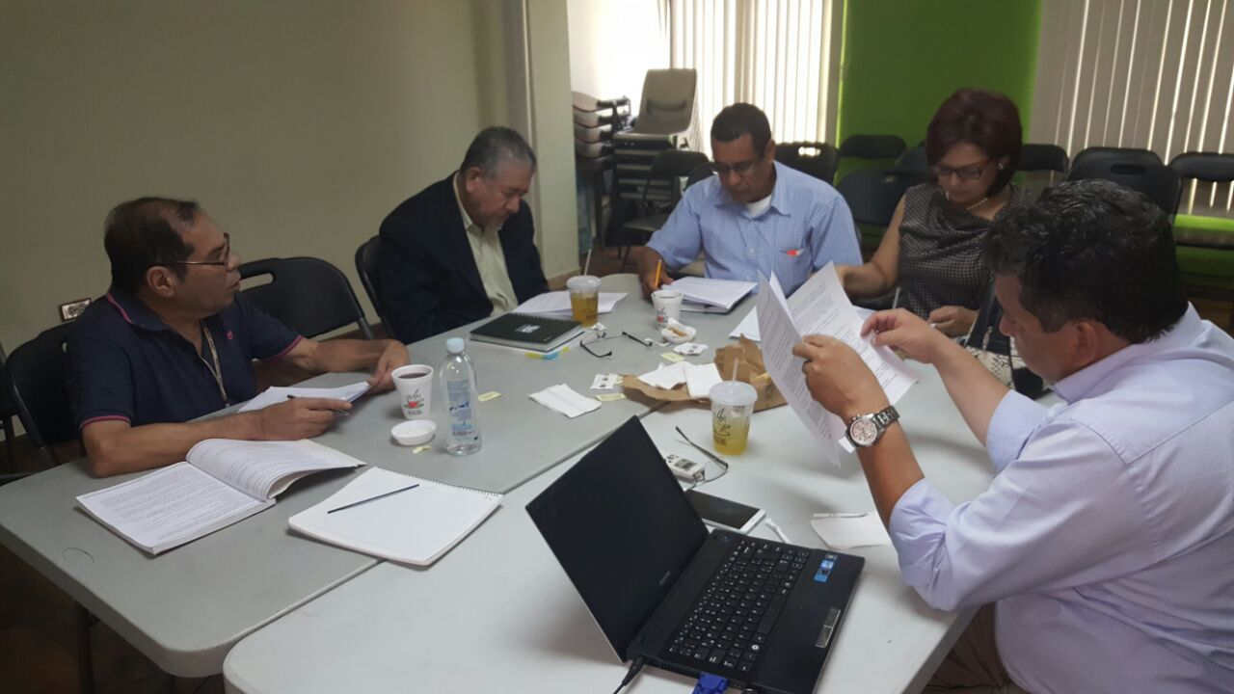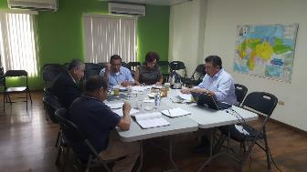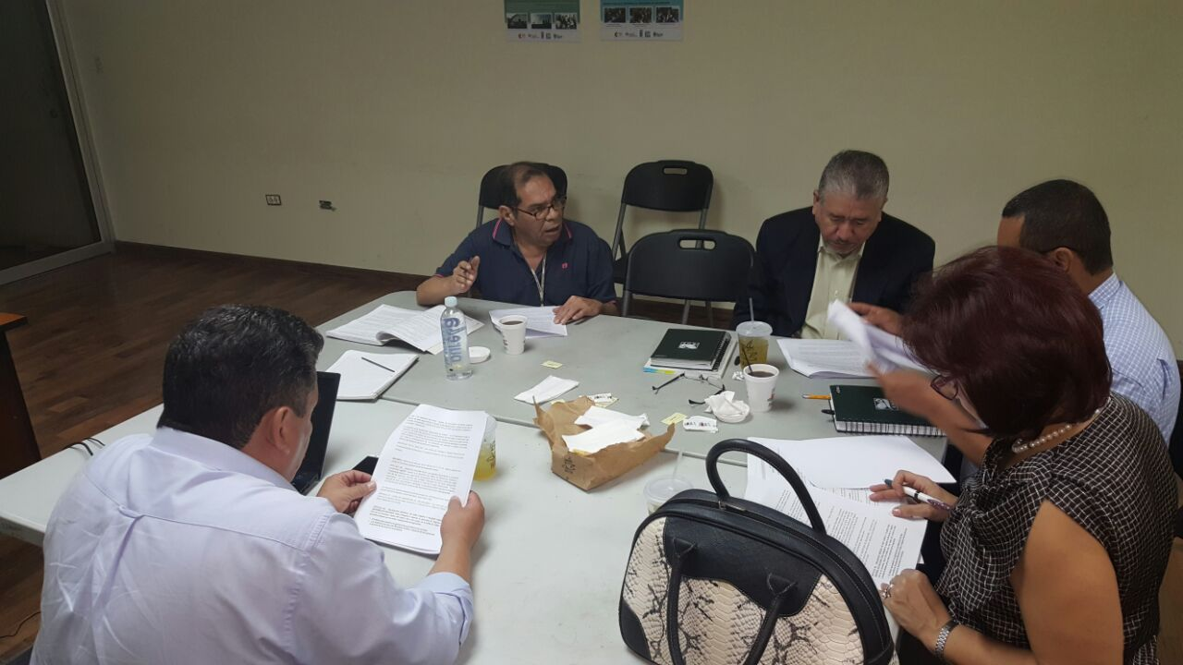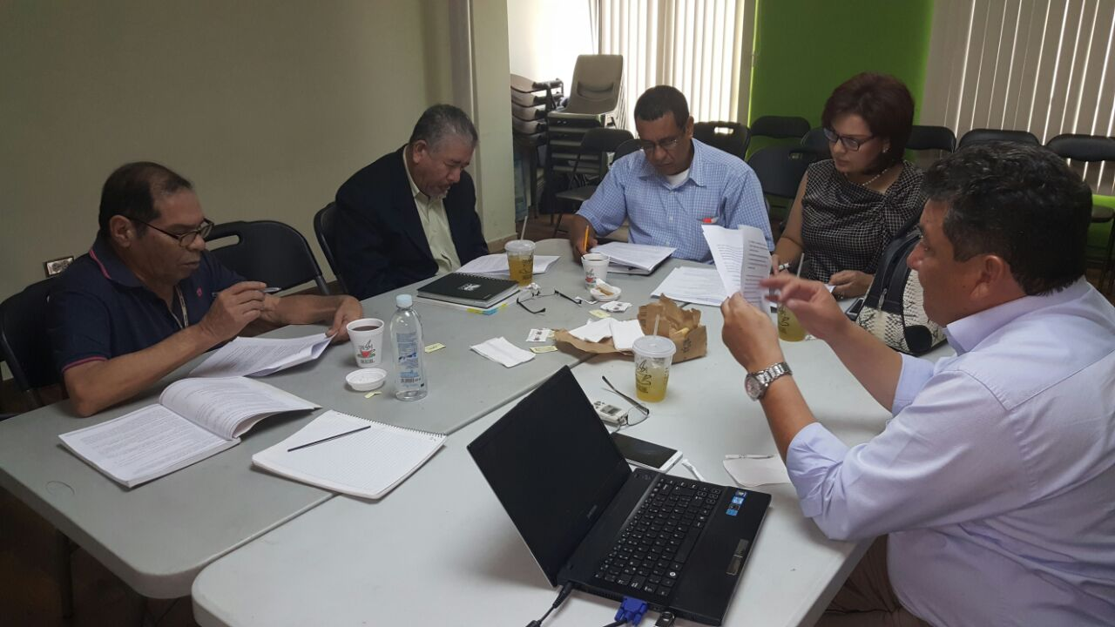

## Annex 4

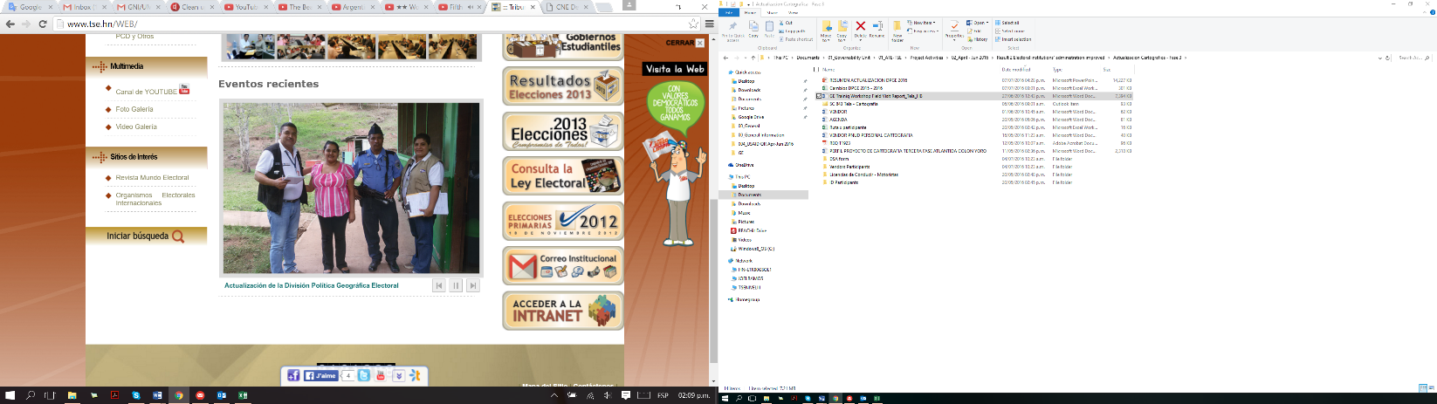

Illustration 2: TSE staff supported by the National Police during the DPGE Updating process in Colon Department.

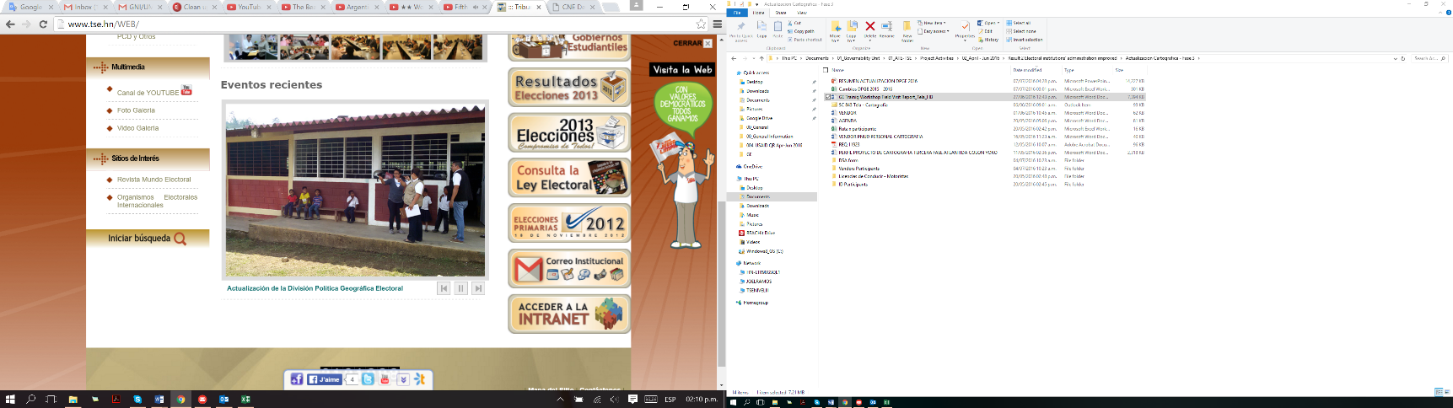

Illustration 3: TSE staff interviewing a teacher to obtain information on the voting center condition.

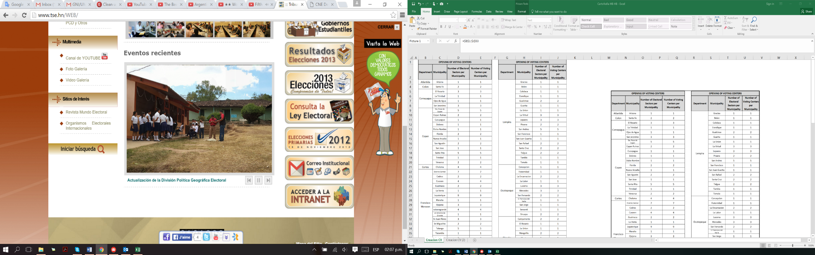

Illustration 4the Voting Center.: TSE staff georeferencing a voting center.

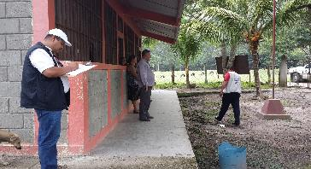

Illustration 5: TSE staff filling in forms with physical condition of the voting center.

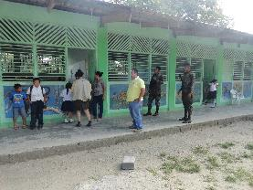

Illustration 6: TSE staff supported by Honduran Army during the updating process of the DPGE in Yoro Department.

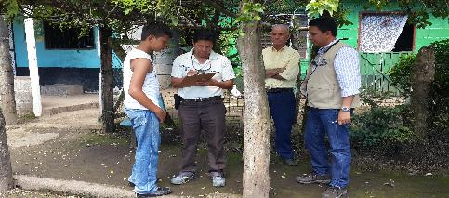

Illustration 7: TSE's Cartography Unit Director supervising the updating process.

## Annex 5

## 

Table 3: New electoral sectors and voting centers identified. Developed by ATE Component.

## Annex 6

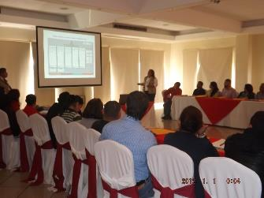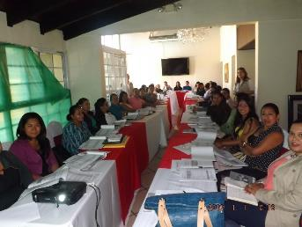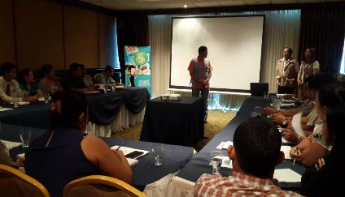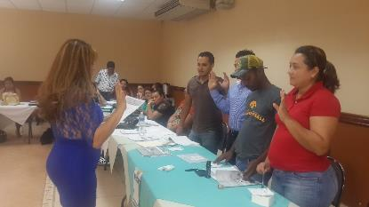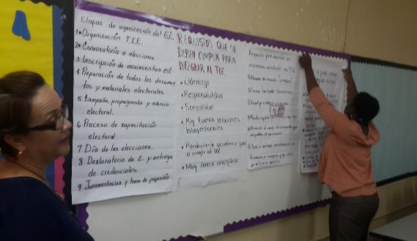

Illustration 8: TSE staff member explaining the Student Government forms to fill in during the Student Elections

Illustration 9: Teachers ready to receive the training workshop in Gracias city, Lempira Department.

Illustration 10: ATE Component staff welcoming teachers to the training session in San Pedro Sula city.

Illustration 11: Teachers participating in the simulation of Student Government elections

Illustration 12: Teacher posting a sheet about democratic values

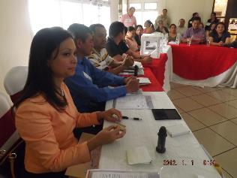

Illustration 13: Teachers playing the role of member at polling stations during the training workshops in Cortes Department.

## Annex 7

Figure 1: Proposed and reached goal on trained teachers for Student Government Election.

Reached goal of trained teachers

Proposed number of trained teachers

## Annex 8

Table 4: Proposed and reached goal on trained teachers for Student Government Election.

|  |  |  |  |  |
| --- | --- | --- | --- | --- |
| No. | Department | Municipality | Proposed Goal | Trained Teacher |
| 1 | Atlántida | La Ceiba | 336 | 331 |
| 2 | Colón | Trujillo | 180 | 200 |
| 3 | Comayagua | Comayagua | 355 | 356 |
| 4 | Copán | Santa Rosa de Copán | 119 | 140 |
| 5 | Cortés | San Pedro Sula | 1,380 | 1,359 |
| 6 | Choluteca | Choluteca | 366 | 405 |
| 7 | El Paraíso | Danlí | 56 | 65 |
| 8 | Intibucá | La Esperanza | 56 | 62 |
| 9 | La Paz | La Paz | 121 | 133 |
| 10 | Lempira | Gracias | 138 | 138 |
| 11 | Ocotepeque | Ocotepeque | 93 | 105 |
| 12 | Olancho | Juticalpa | 360 | 392 |
| 13 | Santa Bárbara | Santa Bárbara | 136 | 144 |
| 14 | Valle | Nacaome | 215 | 240 |
| 15 | Yoro | El Progreso | 428 | 414 |
|  |  | **TOTAL** | **4,339** | **4,484** |

## Annex 9

Table 5: Number of directly trained students in the Municipality of Distrito Central

|  |  |  |
| --- | --- | --- |
| No. | Name of the School | Trained Students |
| 1 | Escuela Tomas Alvarez Dolmo | 90 |
| 2 | Escuela Itzamania | 48 |
| 3 | Centro Educacion Basica Jorge J. Larach | 22 |
| 4 | Centro Basico Club De Leones N°2 | 85 |
| 5 | Instituto Tecnico Los Pinos | 39 |
| 6 | Del Bosque International Shool | 75 |
| 7 | Escuela Camara Junior N°1 | 26 |
| 8 | ESCUELA CERRO GRANDE ZONA Ll | 40 |
| 9 | Instituto Republica De Francia | 76 |
| 10 | Instituto Tenico Rio Abajo | 38 |
| 11 | Escuela Club Rotario N°2 | 34 |
| 12 | Escuela E Instituto Y.E.S | 54 |
| 13 | Escuela Jhon Calin Christian School | 26 |
| 14 | Instituto Tecnico Saul Zelaya Jimenez | 66 |
| 15 | Escuela Germania | 68 |
| 16 | British School | 29 |
| 17 | Abc Educational Center | 55 |
| 18 | Escuela El Verbo | 32 |
|  | **TOTAL** | **903** |

## Annex 10

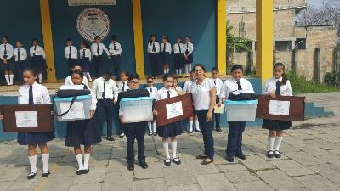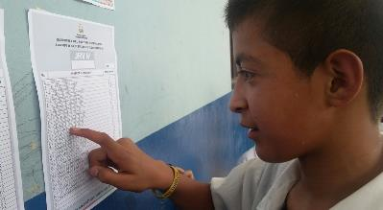

Illustration 14: Student Electoral Tribunal ready to deliver the electoral material to polling stations.

Illustration 15: Student searching his name on the voters list at a polling station in his school.

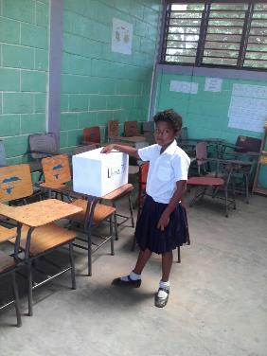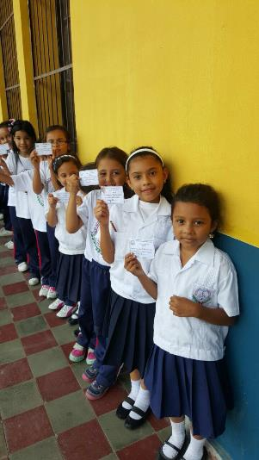

Illustration 16: Student casting her vote into a ballot box.

Illustration 17: Students showing their ID prior cast their vote.

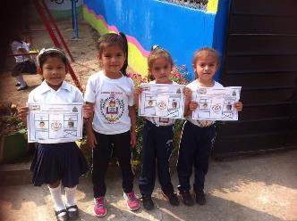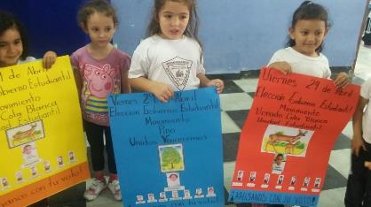

Illustration 18: Students showing how they marked on the ballot paper

Illustration 19: Student representatives of movements at their school.

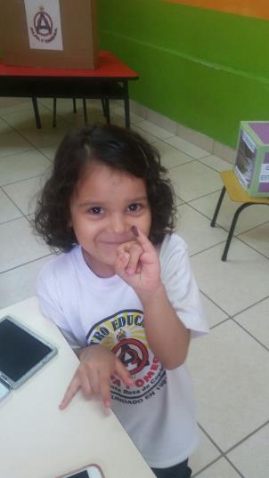

Illustration 20: Student showing her finger after casting her vote.

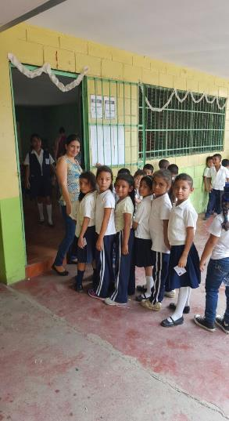

Illustration 21: Students queuing before entering at the polling station.

1. <http://www.hn.undp.org/content/honduras/es/home/presscenter/articles/2016/07/20/el-pnud-contribuye-a-fortalecer-los-procesos-electorales-en-honduras/>

   <http://www.milenio.com/region/INE-autoridades-Colombia-Honduras-Jalisco-procesos_electorales-internacional_0_760124097.html>

   <http://www.1070noticias.com.mx/archivos/337294>

   <http://www.20minutos.com.mx/noticia/104309/0/funcionarios-electorales-de-tres-paises-intercambian-experiencias/#xtor=AD-1&xts=513356>

   <https://noticias.terra.com/mundo/latinoamerica/funcionarios-electorales-de-tres-paises-intercambian-experiencias,82566cbfd216b4a64cfbddb9576a682ecnmwtnk2.html>